Task 4: Create Two Files in the Local Git Repository

Outcome
Two files are created successfully inside the local Git repository.

Objective
To create two files in a cloned Git repository using Git Bash and verify that Git detects them.

Prerequisites
- Git is installed on the computer.
- A GitHub repository has already been cloned to the local computer.
- Git Bash is available.

Step-by-Step Implementation

Step 1: Open Git Bash and navigate to the repository
Open Git Bash and move into your cloned repository folder. Replace my-project with your actual folder name.

cd ~/Desktop/linux-practice
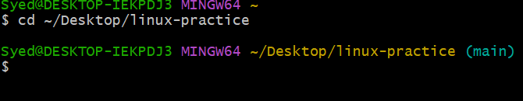

Step 2: Create two files
Run the following command to create two empty files:
touch file1.txt file2.txt
This creates file1.txt and file2.txt in the current directory.

Step 3: Verify that the files exist
ls
Expected output includes:
file1.txt
file2.txt
Other existing repository files may also appear in the output.
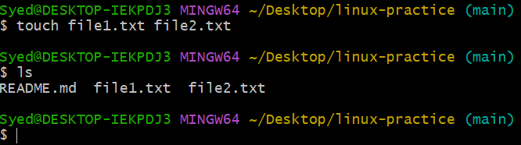

Step 4: Add content to the files (Optional)
Run these commands to add a line of text to each file:
echo "This is the first file" > file1.txt
echo "This is the second file" > file2.txt
To display the content of both files, run:
cat file1.txt file2.txt

Step 5: Check Git status
git status
Expected result: Git lists file1.txt and file2.txt under “Untracked files” if they have not been added to staging.
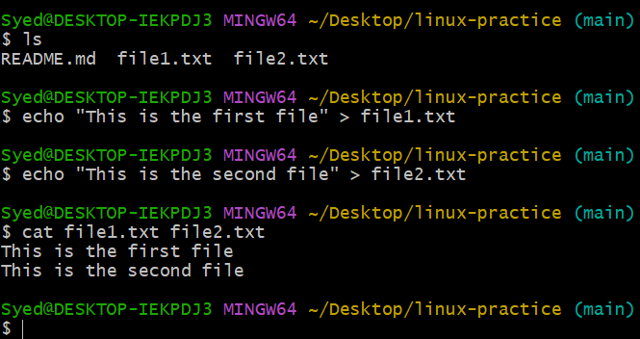.

Result
Two files, file1.txt and file2.txt, have been created in the local Git repository and verified using Git Bash.
Note: Replace the example repository folder name with your actual local repository folder.

